MULTI-LABEL

CLASSIFICATION

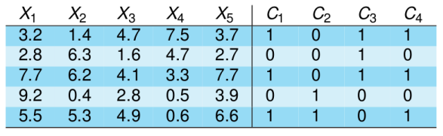

OUTLINE – MULTI-LABEL

■ Basic vocabulary and framework

■ Applications

■ Evaluation metrics

■ Overview of techniques

■ Software and references

SINGLE versus MULTI-LABEL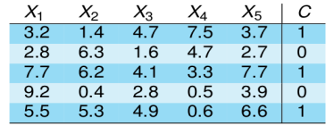



MULTI-LABEL CLASSIFICATION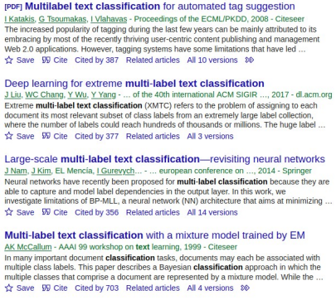

FRAMEWORK

***X*** *:* d-dimensional input space

***Y****:* output space of *q* labels {λ1,λ2,...,λq} ***S***: multi-label training set of *m* samples, *{(****xi,yi****)|1≤i≤m}*

*h:* multi-label classifier*, h:* ***X*** *2 → Y*

or ranking the associated labels to a sample ***x,***

e.g. *r****x****(*λ2) < *r****x****(*λ4) < *r****x****(*λ1) < *r****x****(*λ3)

FRAMEWORK

Given a set of initial labels *L*={*λ*1, *λ*2, *λ*3, *λ*4, *λ*5} Given a new instance ***x***

Multi-label classification outputs a → *bipartition* of the set of labels, i.e. positive and negative ones, *P*x: {*λ*1, *λ*4} and

*N*x: {*λ*2, *λ*3, *λ*5}

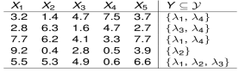

APPLICATIONS - TEXT

***ACM COMPUTING CLASSIFICATION (Veloso et al. 2007)***  A *document* described by its title, abstract, citation, autorship: huge feature space

■ First hierarchy level, 11 labels: general literature, hardware, software, information systems...

■ Second hierarchy level with 81 labels

■ 81,251 digital archives



APPLICATIONS - TEXT

REUTERS CORPUS (Lewis et al. 2004)

■ 804,414 newswire stories

■ To be indexed in 103 topic codes

■ Words: huge and sparse feature space

■ A benchmark in multi-label learning



APPLICATIONS – e-MAIL

ENRON COMPANY e-MAILS

■ UC Berkeley Enron e-mail analysis project

■ Company-professional e-mails of about 150 Enron senior managers

■ 1,702 samples, 53 labels

■ Public datasets during a Federal Energy Regulatory Commission investigation



OTHER APPLICATIONS

■ BIOLOGY:

– Annotation of protein functions

– Gene ontology annotations (e.g. of a gene)

■ DIRECT MARKETING:

– Product offers to customers



OTHER APPLICATIONS

■ IMAGE AND AUDIO:

– Simultaneous object class recognition

– Demographic classification of facial images: sex, age, ethnicity...

– Music categorization: instruments, country, rhythm... – Categorization of song emotions: happy, calm, amazed...

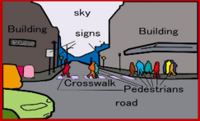

BENCHMARK DATASETS

■ MULAN multi-label datasets

■ MEKA multi-label datasets

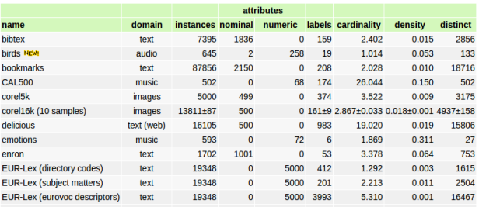

BENCHMARK DATASETS

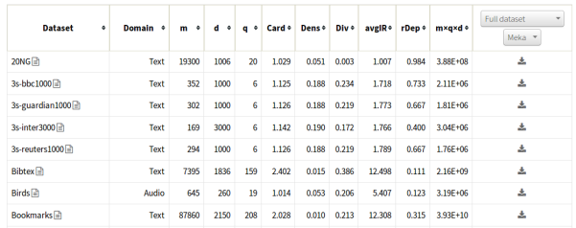

EVALUATION METRICS

■ *X :* d-dimensional input space ***X****=(X1,...Xm)*

■ *Y :* output space of *q* labels {λ1,λ2,...,λq}, real labels, *Y=*{λ7,λ9}

■ S : multi-label training set of *m* samples, {*(xi,Yi)|1≤i≤m}*

■ *h:* multi-label classifier*, h: X 2 → Y*

■ *Predicted labels for a example, Predh(Y)=*{λ6,λ9,λ11,λ15}

■ Evaluation metrics:

– Example-based:

→ calculated separately **for each sample** and averaged – Label-based:

→ calculated separately **for each label** and averaged

EVALUATION METRICS

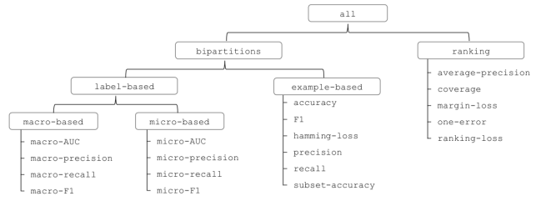

0/1 SUBSET ACCURACY

EXACT MATCH - PER SAMPLE 

■ EXACT MATCH = 1/5 x (0+1+1+0+0)

■ For each sample checks whether the predicted set of labels → is an exact match of the true set of labels

■ Very strict evaluation

ACCURACY – PER SAMPLE 

■ Scores from the “Information Retrieval” area →  Using AND and OR logical operations

HAMMING LOSS PER SAMPLE



■ HAMMING LOSS = 1/4 x 1/5 (2+0+0+1+1)

■ Symmetric difference between both sets: XOR operation  Average binary classification error

LABEL-BASED METRICS

METRICS PER LABEL



LABEL-BASED METRICS METRICS PER LABEL



■ ACCURACY [LABEL4] = (2+1)/(2+1+2+0)  PRECISION [LABEL4] = (2)/(2+2)

■ RECALL-SENSITIVITY [LABEL4] = (2)/(2+0)

LABEL-BASED METRICS

MACRO vs. MICRO





TECHNIQUES - TAXONOMY

1. Problem transformation methods:

– In several single-label tasks

– Algorithm independent

2. Algorithm adaptation methods:

– Extending supervised algorithms to multi-label data – Decision trees, SVM, Bayesian networks, K-NN...

TECHNIQUES - TAXONOMY

PROBLEM TRANSFORMATION

BINARY RELEVANCE - BR

■ Learning one binary classifier per class 

■ Output the union of their predictions

■ Not consider label relationships

■ Ensemble of BR base classifiers common →



PROBLEM TRANSFORMATION LABEL POWERSET – LC-LP



■ Each set of labels recodify as a different class value →  e.g. “1001” classA, “0011” classB, etc... → →

■ → a new single-class-variable classification task  Limited training samples for many new labelsets  High complexity

■ Can not predict unseen labelsets

PROBLEM TRANSFORMATION PRUNED SETS – PS



■ Start considering all labelsets too many!! Reduce labelsets → →  Prune examples belonging to less frequent classes (e.g. < 7)

■ Distribute pruned examples along more frequent subsets of their labelset →  Reduce the number of labelsets and focus on frequent ones  Train a label Powerset multi-label classifier

PROBLEM TRANSFORMATION CLASSIFIER CHAINS - CC



■ Given a dataset with |L| labels: y1,y2,...,y|L|

■ Dataset is transformed in |L| datasets where instances in the “j” dataset are of the form:

((xi,y1,y2,...,yj-1), yj)

■ Classifiers build a CHAIN each learns a binary classification of a single label →

■ Features in each classifier EXTENDED with binary labels indicating the → prediction of previous labels-classifiers in the chain

■ Partial label dependence is maintained, but... order of the chain?

ALGORITHM ADAPTATION

■ Extending supervised algorithms to deal with multi-label data  Literature shows plenty of examples – Just a couple: – K-NN: assigns to ***x*** the most common labels of its K neighbours

– Decision trees: extending the concept of multi-label entropy. Multiple labels at leaves



REMARKS

■ Hot topic – specially in NLP

■ Closely related with “tagging”-”annotation”, news’ categories, web 2.0, multiple outputs, learning from crowds, recommender systems...

■ Many real world applications

■ Software:

– MULAN: WEKA-based library

– MEKA: WEKA-based framework and GUI

– Utiml, mldr, mldr.datasets R packages

■ Datasets' repositories:

– http://mulan.sourceforge.net/datasets.html

– http://meka.sourceforge.net/#datasets

– http://www.uco.es/kdis/mllresources/

EXTENDED INFO

■ Talks-Tutorials:

– C. Bielza, P. Larrañaga, UPM-Madrid [link]

– J. Read, MEKA's programmer [link]

– G. Tsoumakas et al., tutorial [link]

■ Review:

– M-L. Zhang, Z-H. Zhou (2013). “A review on multi-label learning algorithms”. IEEE Transactions on Knowledge and Data Engineering, 26(8), 1819-1837

– F. Herrera, F. Charte, A.J. Rivera, M.J. Del Jesús (2016). Multi label Classification. Springer

SOFTWARE





SOFTWARE + EXERCISE

EXERCISE

■ “utiml” + “mldr” + “mldr.datasets” R packages

■ Consult its R-vignette [R-Journal][CRAN]

■ It is so linked with “mldr” package: loaded both together

■ Choose a multilabel dataset (e.g. “Enron”) understand the problem →  Understand its specific “multilabel preprocessing filters”  Choose two multilabel strategies

■ Choose a supervised base classifier type

■ Create a train + test partition

■ multilabel_evaluate( ) + predict( ) functions

■ Understand its associated parameters

■ Compare both multilabel strategies types of offered metrics? →